**Project: Food Printing Systems**

**Project Description**

The Food Printing Systems project aimed to develop a system that enhances customization of food labels. Utilizing the Evebot Food-Grade Portable Printpen, A prototype was created that is capable of printing customized food labels on fruits. This project underscores my ability to innovate within the food industry and address accessibility challenges.

**Objectives**

1. Analyze a Food Industry Segment Using Systems Engineering Principles:

- Conducted a thorough analysis of the food printing industry to identify potential areas for innovation.

- Applied systems engineering methodologies to ensure a comprehensive understanding of the project's scope and requirements.

2. Develop a Working Prototype Demonstrating Key Features and Functionality:

- Designed and built a functional prototype that integrates the Evebot system with a custom-developed funnel mechanism.

- Ensured the prototype met all specified criteria, including food safety standards and usability for visually impaired users.

**Project Focus: Food-Grade Portable Printpen**

A handheld inkjet printer designed to customize food surfaces. This technology was leveraged to create a system that prints directly on food items, replacing traditional label stickers.

**Exploratory Research**

Starting off the project, exploratory research on 2D food printing systems was first conducted. 2D Food printing systems are split into two types, inkjet and airbrush food printers.

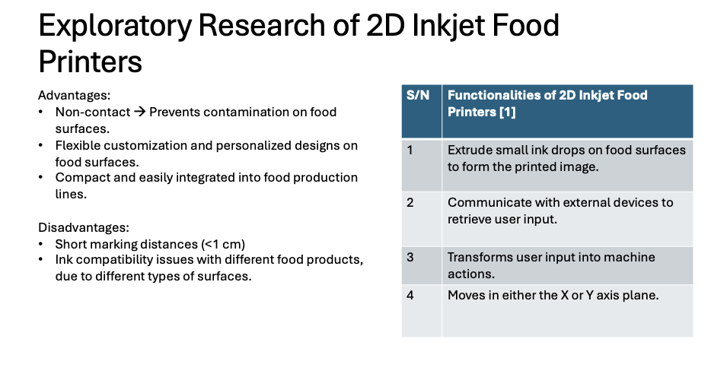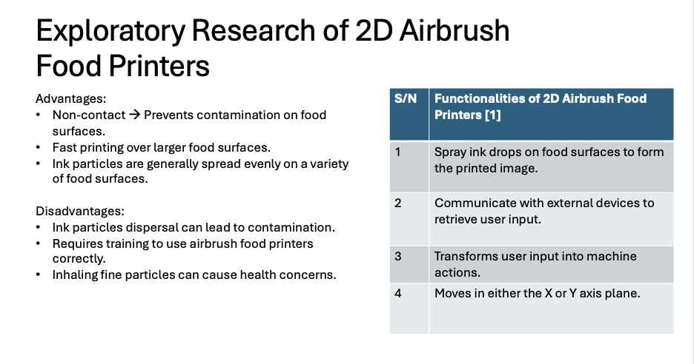

The two tables above show the functionalities of the two different printing systems. Following this, the conclusion of food printing systems was made, which is that **food printing systems will perform customization towards the shape, color, or texture of food materials**. Next, research on some potential problems faced by the food industry was conducted.

**Exploratory Research on New ideas**

After knowing the capabilities of food printing systems, research on problems faced within the food industry was explored.

**Print labels on food**

Food labels are regularly pasted on food products to convey product information to customers, and for stock tracking. These single use food labeling has seen prevalent usage in the logistics sector of food industries such as supermarkets. The labeling on these products helps enable customers to make informed decisions and builds trust between customers and brands. However, the present method of labeling serves more contradictions than positivity.

The excessive usage of single use food labeling within the logistics sectors of the food industry raises some potential concerns in wastage and convenience. Traditional stickers on ready-to-eat food items can be inconvenient and pose a contamination risk. These plastic labels are also torn off before consumption, which creates inconvenience for both the customer, and the environment.

The two tables above show the overall number of waste generated, and the overall recycling rate in the past decade. Degradation of disposable plastic products releases microplastics, which damages both wildlife and humans. Although green washing is not the objective of this project, the numbers left much room for improvement.

**Concept of operation: Stakeholders involved**

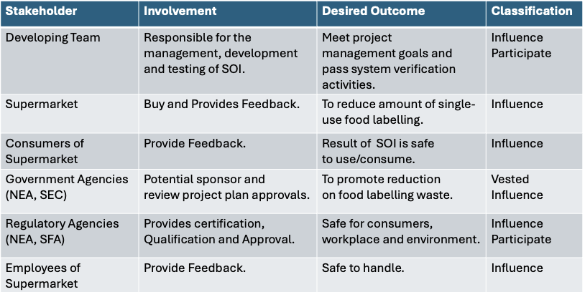

The objective of this Systems Engineering project will be targeted towards the supermarket industry, hence the above stakeholders were identified due to their involvement within the project.

**Problems and opportunity**

Problem: Food labeling is essential to build trust between brands and customers and they are typically made of plastic, which will be eventually disposed of after purchase

Opportunity: Replace the present method of food labeling with an alternate solution that does not involve the use of plastic

This project is significant for several reasons:

1. Systems Engineering Application:

- Demonstrated ability to analyze, design, and implement complex systems, a key skill for any engineering role.

2. Innovation:

- Identified gaps in the food printing market and developed creative solutions to address them.

3. Technical Skills:

- Showcased proficiency in research, prototyping, and integrating new technologies.

4. Inclusivity:

- Focused on developing accessible solutions that cater to diverse user needs, particularly the visually impaired.

Existing solution: Laser marking system

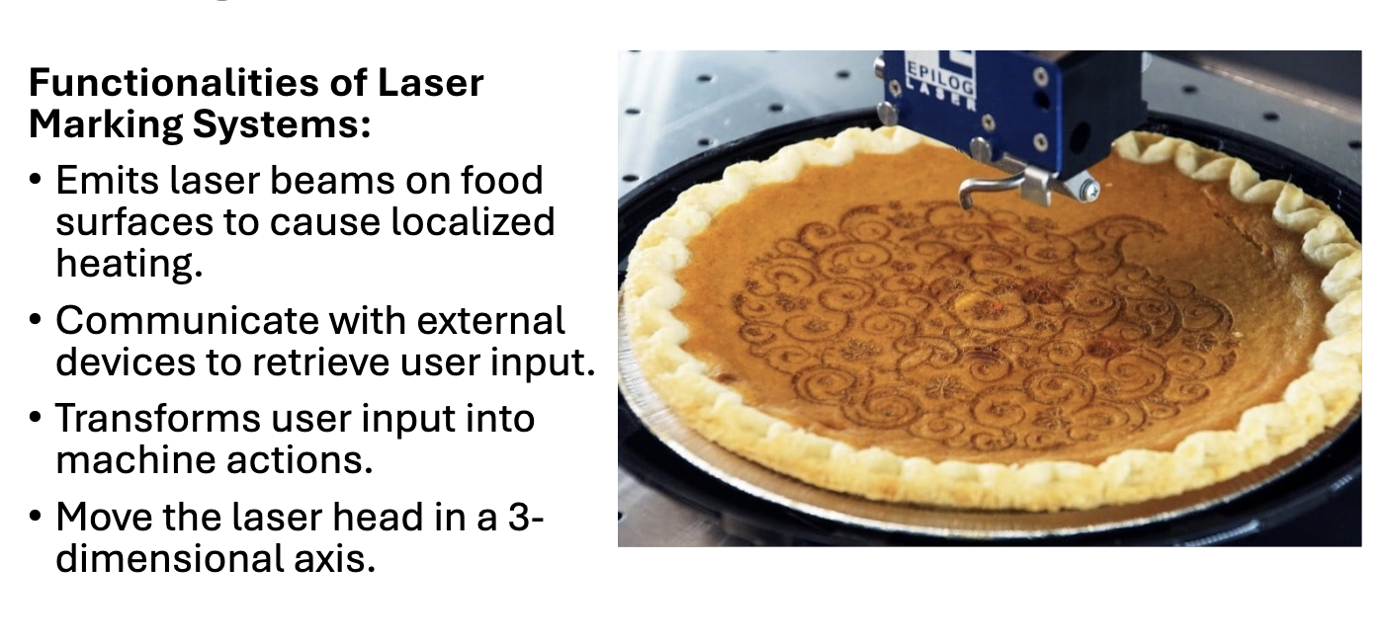

Laser marking system is an existing solution used to engrave words or images onto food surfaces. This system is ideal for large scale engraving and speed. However, it is noted that the laser engraving method is not suitable for every surface, most notably brittle surfaces. In addition, Its high upfront cost does not entice smaller distributors to adopt it, making it catered to mainly huge enterprises. Finally, laser engraving essentially burns the surface of the product, which might affect the quality of the end product.

Advantages of Laser marking systems: Produces a permanent mark on a wide range of materials

Disadvantages of Laser marking systems: Degrades the quality of the surface skin of fruits, creating an undesirable look

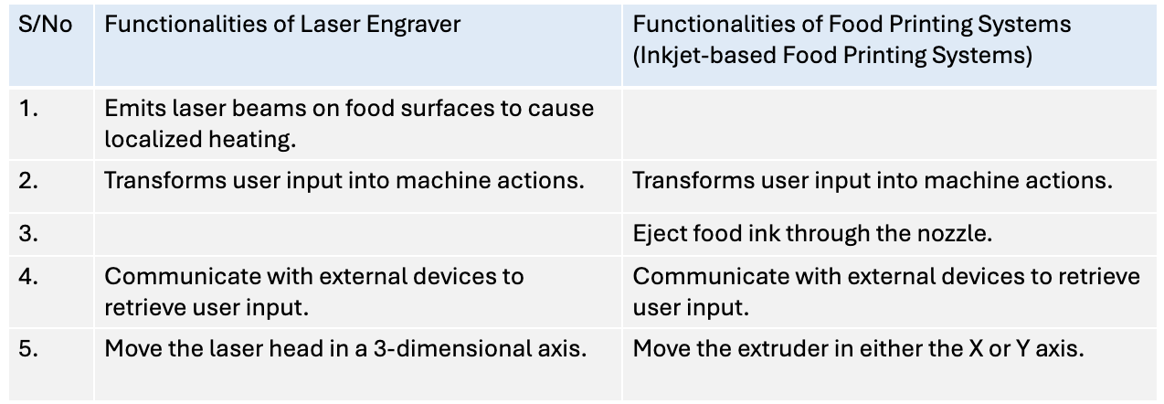

The functionalities of the laser engraver and inkjet food printing systems were compared to find the similarities between the two, thereby matching the set of functionalities. Finally, the problem the project will be tackling will be the **extrusion of food grade materials to create permanent labeling on food surfaces.**

**Food grade material selection**

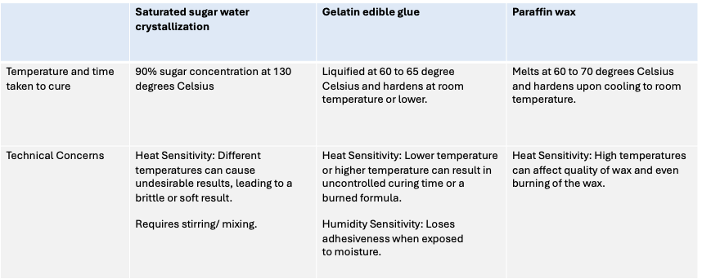

**Preliminary Concept**

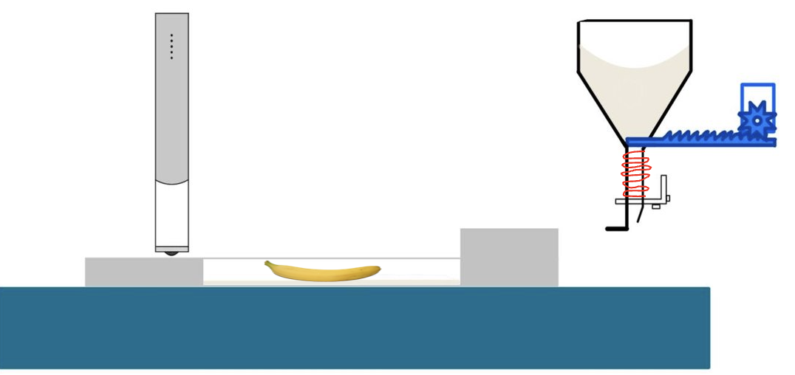

The concept will be Incorporating a printpen to create food safe labels to replace traditional plastic labels, and creating a coating layer using wax to ensure the print does not fade. As wax has to be heated up to liquify, a heating mechanism has to be in place.

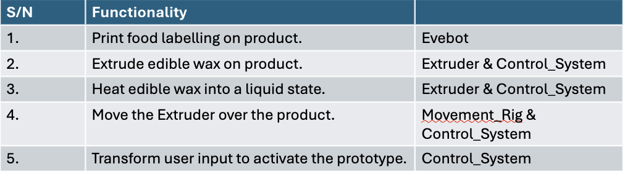

**Concept selection**

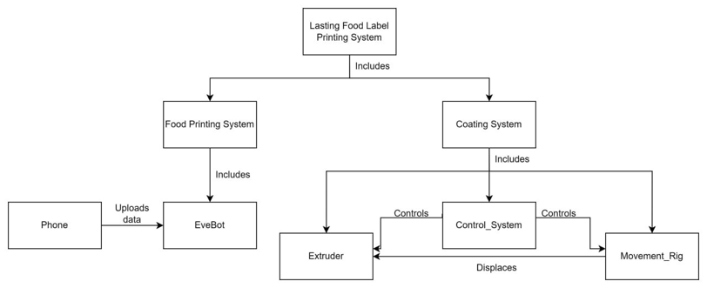

The concept model created shows the relation between the prototype and the food printing system, ultimately creating a lasting food label. The operator will be piloting both the printpen and the control system, and the output of both printpen and the prototype will be printed on a fresh fruit. The arrows represent the interactions between the different subsystems.

**Sequence Diagram**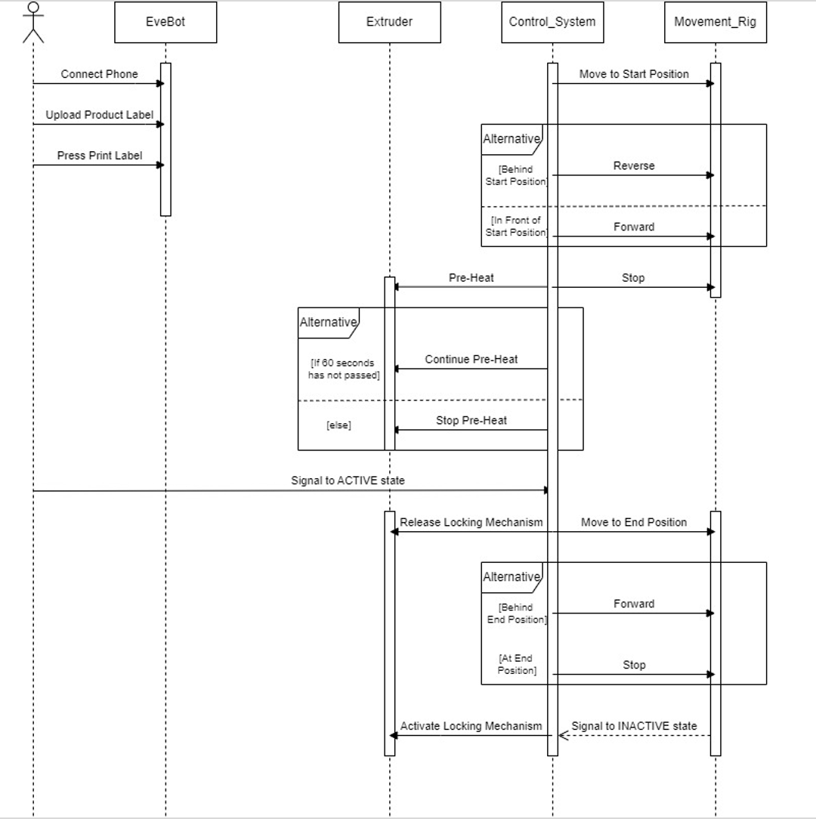The sequence diagram shows the interactions between the operator and objects in the sequential order. The operator will start the food printing system (Evebot) and the prototype at the same time. The operator will first connect Evebot to the phone, upload the product label and press “print label”. At the same time, the prototype will be turned on and position itself towards the starting position. Pre-heating will be performed for 60 seconds and once done, it will signal to an active state. The locking mechanism will then be released until the end where the inactive state will be called again, activating the locking mechanism and signaling the end of the process.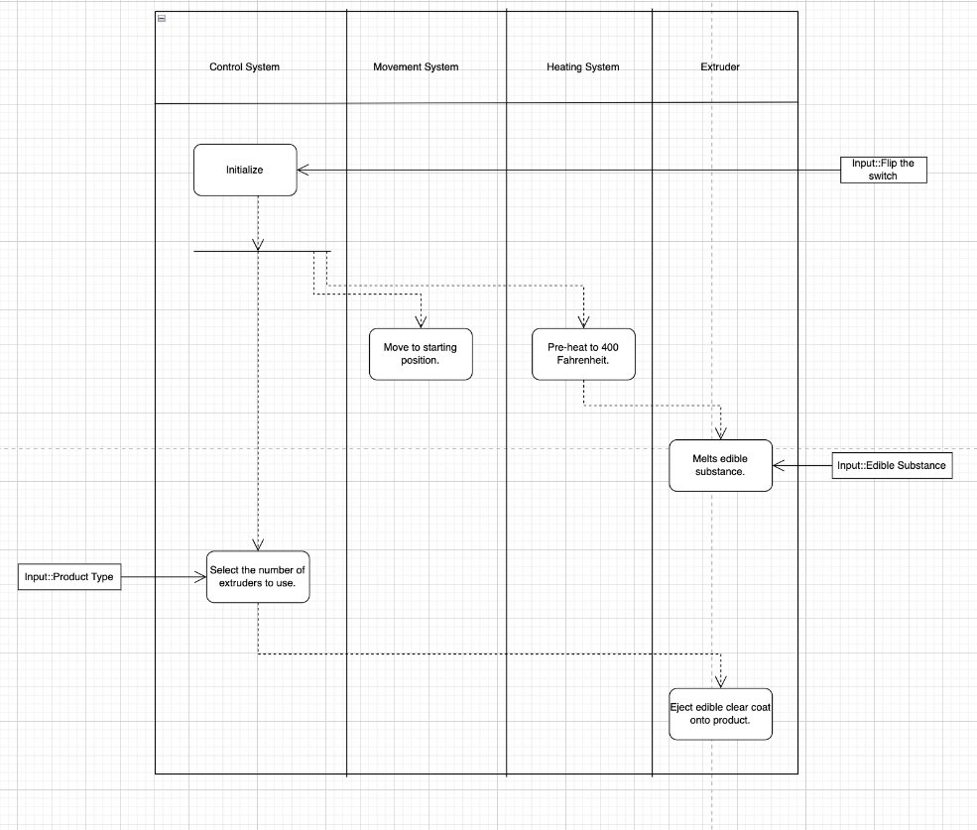

The operation of concept (OpsCon) is crafted based on the concept model and stakeholders identified. When the prototype is turned on, it will first move to the starting position and preheat to 400 fahrenheit. Once heated, the edible substance will be melted and ready to be extruded. The operator will then select the number of extruders to use (Small, Medium, Large) and the edible clear coat will be ejected onto the product upon confirmation.

**Design Output Specifications**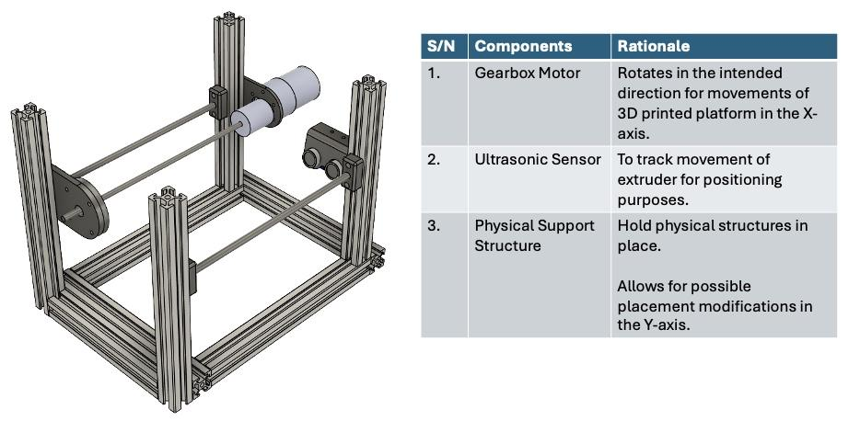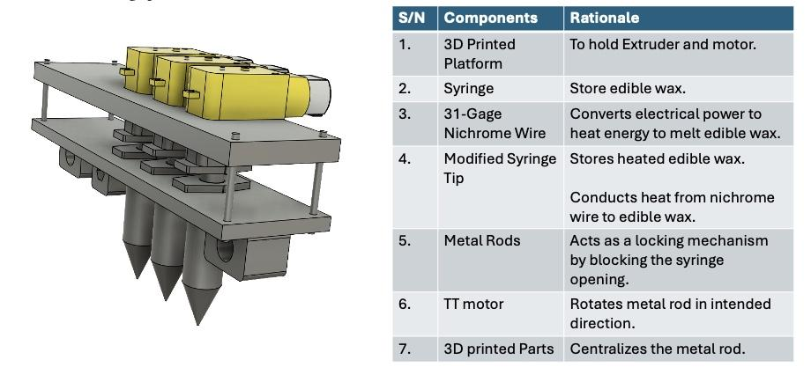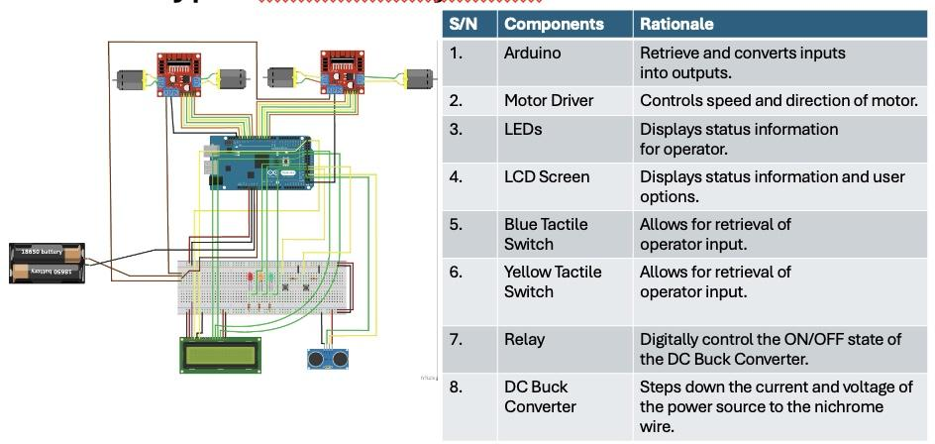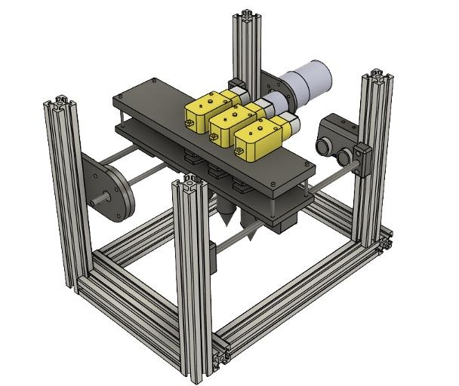

In design output, the CAD drawing of the body frame, and the different methods of extrusion was drawn. The above diagrams are cad drawings for the prototype. It features a movement system with the usage of a 12 volt DC gear-box motor, which will provide rotational torque to move the platform in the X axis. The platform will be used to accommodate the extruder system, which will be required to navigate in the Y axis. The prototype will feature a linear displacement mechanism for extrusion. The extruder will be mounted onto the rod, and the TT motor will be mounted at the top of the syringe, which acts as an opening and closing mechanism for the syringe.

**N2 Diagram**

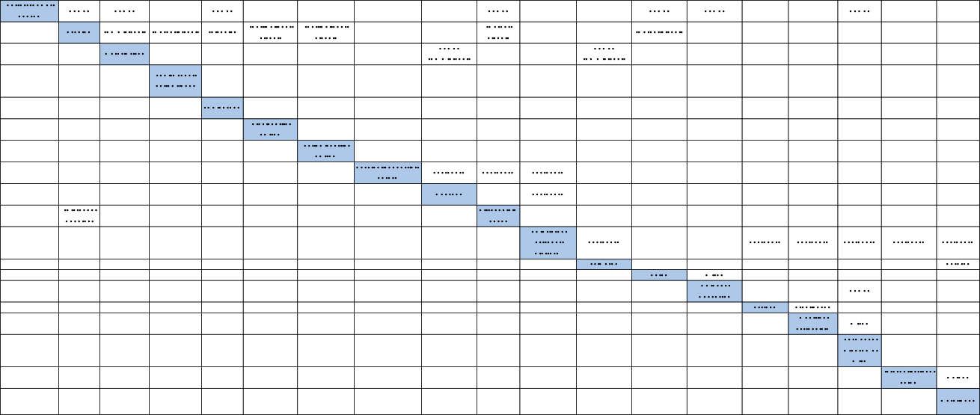

N2 diagram represents the logical data flow for the prototype. This is drawn to analyze the functional and physical interfaces in the solution.

**Solution Concept**

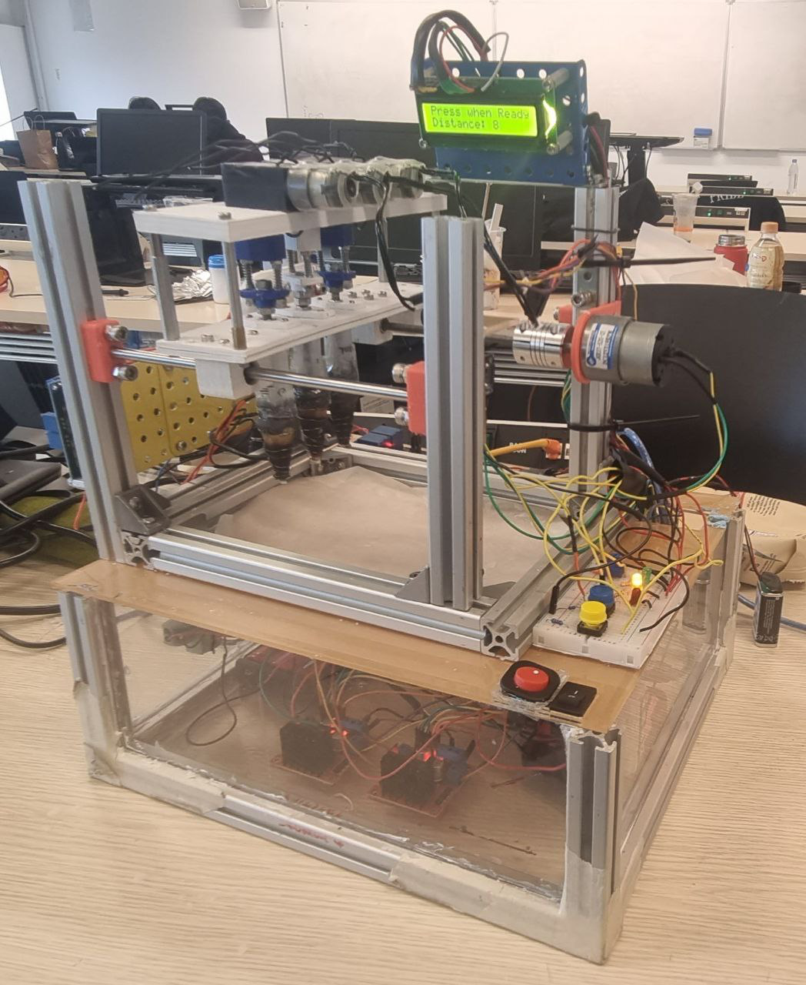

The image above shows the prototype created. There are three extruders in total, mounted atop the rods above ground. The TT motors are mounted onto the extruders to facilitate the opening mechanism for the wax to flow through. As wax is solid at room temperature and requires some heating to be dispensed in liquid form, the step down motors are mounted at the side to help heat the extruder to 400 fahrenheit. The prototype is then validated with different test cases to determine the feasibility of it.

**Verification Checklist**

For each functionality, different test cases were made to verify said functionality.

| **Functionality** | **Test Description** | **Method** | **Pass/Fail** |
| --- | --- | --- | --- |
| Print food labeling on products. | Operator will upload a picture of the product label in Evebot PrintPen application. The application must reflect the product label. | Demonstration | Pass |
| Operator will place an auxiliary ruler on the banana. Operator will then roll the Evebot on the auxiliary ruler, and the banana must reflect the product label clearly. | Demonstration | Pass |

| **Functionality** | **Test Description** | **Method** | **Pass/Fail** |
| --- | --- | --- | --- |
| Heat edible wax into a liquid state. | The Arduino will activate the relay to the active state. The DC buck converter will activate and display a blue light. | Demonstration | Pass |
| The Arduino will start a 60 seconds preheat countdown.  The LCD screen will display  the countdown status. | Demonstration | Pass |
| The Arduino will deactivate the relay after 60 seconds has elapsed. The DC buck converter will deactivate and not display any LED indication. | Demonstration | Pass |
| After initial pre-heat, the Arduino will toggle the relay every 2 seconds to ensure the edible wax remains in a liquid state. The DC buck converter will display a blue light every 2 seconds to indicate toggling. | Demonstration | Pass |

| **Functionality** | **Test Description** | **Method** | **Pass/Fail** |
| --- | --- | --- | --- |
| Transform user input to activate the coating process. | The yellow LED will be lit when the system is waiting for a user input. The operator will depress the blue tactile switch. The LCD will indicate “Choice” for the operator to depress the yellow tactile switch for extruder selection. | Demonstration | Pass |
| Upon seeing the “Choice” in the LCD, the operator will depress the yellow tactile switch to cycle through the extruder selection. The LCD will display “Small”, “Medium”, or “Large” accordingly. The green LED will light up to indicate the system is active. | Demonstration | Pass |

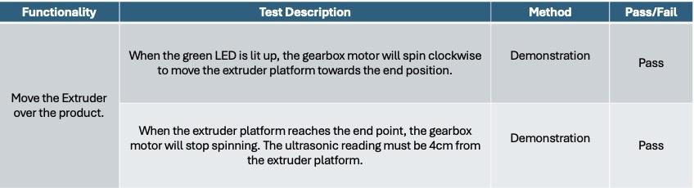

| **Functionality** | **Test Description** | **Method** | **Pass/Fail** | **Remarks** |
| --- | --- | --- | --- | --- |
| Extrude edible wax on product. | When the yellow LED is lit up, the operator will place the banana under the extruder. Upon pressing the blue tactile switch, the green LED will light up. Edible wax must flow out of the extruder and fully coat the product label. | Demonstration | Fail | The banana product label failed to be fully coated by the edible wax. |

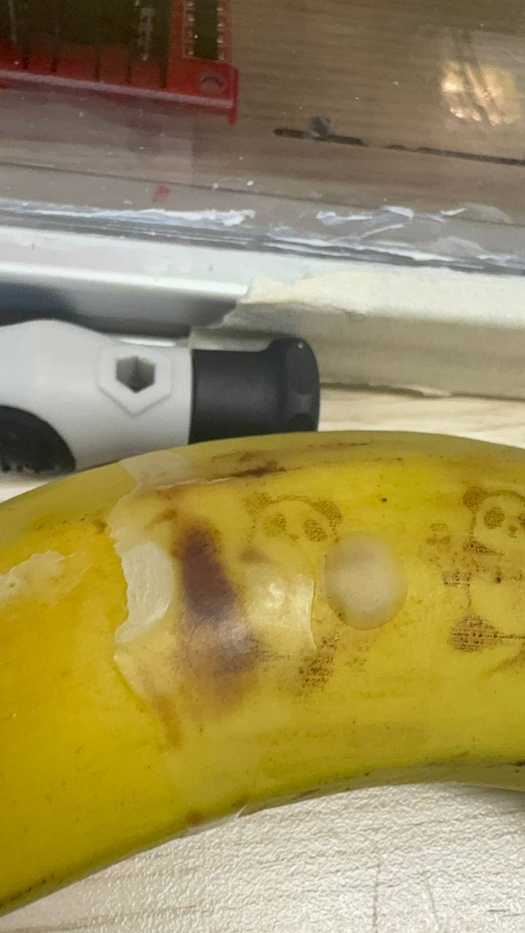

Through the test cases, the functionalities “print food labeling on products”, “heat edible wax into a liquid state”, “transform user input to activate the coating process”, and “move the extruder over the product” were satisfied. The functionality of extruding edible wax on product was not fully satisfied however, as the output failed to be fully coated by the edible wax as shown in the image above. The proof of concept is deemed to be a success, and is ready to proceed to the next phase.

**Project management plan**

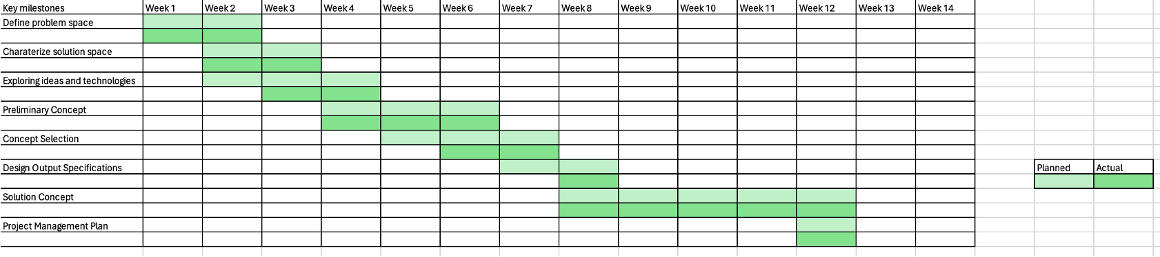The gantt chart presents the schedule of the entire 14 week process of the food printing system project, with problem space being explored and defined in week 1, to the solution concept and project management plan being done in week 12. The project encountered several issues in between and iterations had to be made, but did not ultimately overrun.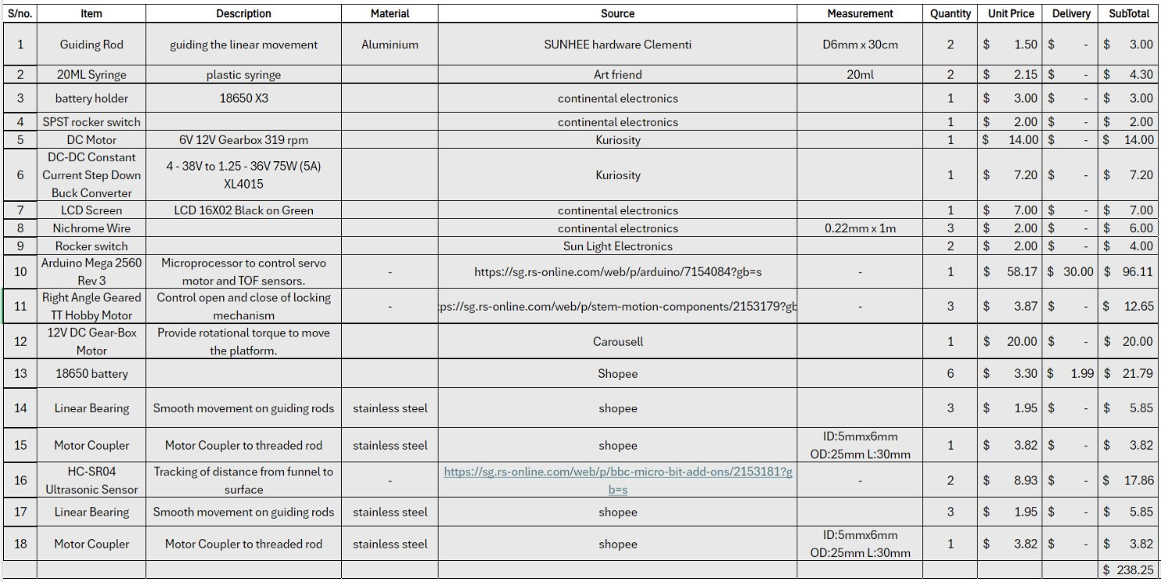

The bill of materials is crafted in accordance with the future system, which will serve as a reference to the budget necessary to make this system.

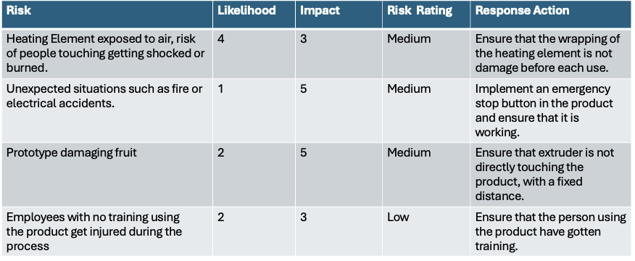

In risk management, the following mitigation plans were crafted to mitigate the potential risk of the system. Different responses were made in response to their overall risk rating, which is determined through multiplying the likelihood and impact rating of each risk.

**Personal Contributions**

1. Research Lead:

- Investigated existing food printing systems and accessibility solutions.

2. Concept Development:

- Selected and developed the binder jetting solution, ensuring it met the project's requirements.

3. Prototype Design:

- Designed and integrated a funnel mechanism with the Evebot system, enhancing the prototype's functionality.

Skills and Learning

1. Project Management:

- Managed the project from concept to prototype, ensuring timely and effective execution.

2. Research and Analysis:

- Conducted extensive research to identify the best solutions and validate the prototype's effectiveness.

3. Prototype and Design:

- Applied engineering principles to design and develop a working prototype.

4. Collaboration:

- Worked effectively with team members and stakeholders to bring the project to fruition.

**Future Work**

The next steps for this project include further testing and refinement of the prototype, conducting user trials, and exploring additional applications for printing food labels. The functionality of extruding edible wax on product should also be revisited as it was not satisfied. The plan is to pitch this innovative idea to potential stakeholders, aiming to secure support for further development and commercialization.